**SRS DOCUMENT FOR ONLINE SHOPPING MART**

**ABSTRACT**

In the contemporary digital landscape, online shopping marts have emerged as pivotal platforms that revolutionize traditional retail experiences. This Software Requirements Specification (SRS) document delineates the essential functionalities and features required for the development of an online shopping mart. The envisioned system aims to provide users with a seamless and convenient shopping experience while offering administrators robust tools for managing products, orders, and customer interactions. Key components of this online shopping mart include **user authentication, product browsing, search functionality, cart management, secure payment processing, order tracking, and administrative controls.** Moreover, security and data privacy are paramount considerations in the development of this online shopping mart. Implementation of secure authentication mechanisms, encryption protocols, and compliance with relevant data protection regulations are integral aspects of the system design. This SRS serves as a foundational blueprint for the development, testing, and deployment phases, ensuring the successful realization of an efficient, secure, and user-centric online shopping platform.

**SYSTEM REQUIREMENTS**

In the realm of software development, requirements play a crucial role in defining the functionalities and characteristics of a software system. Those requirements are broadly classified into two categories:

* + 1. functional
    2. non-functional requirements.

**1.FUNCTIONAL REQUIREMENTS**

Basically, Functional requirements define about the specific actions or functionalities a system must perform. Essentially answer the question "what" the system should do. Functional requirements required for Online shopping mart System are,

1. User Authentication
2. Product browsing and Search
3. Cart management
4. Checkout and Payment processing
5. Order tracking
6. User reviews and Ratings
7. Customer Service

**2.NON-FUNCTIONAL RERQUIREMENTS**

Non-functional requirements describe how a system operates rather than what it does. They outline the system's characteristics and qualities, focusing on performance, usability, reliability, and other aspects that influence the user experience. Some non-functional requirements are

1. Security
2. Scalability
3. Usability
4. Reliability
5. Accessibility

**MODULAR DESCRIPTION**

**1.USER AUTHENTICATON**

It handles user authentication processes including registration, login, logout, and password recovery. It verifies user credentials securely and manages usersessions.

**2.PRODUCT BROWSING AND SEARCH**

This module facilitates product browsing and searching functionalities. It provides a search feature for the users to find products by name, category, etc. enhancing user experience and accessibility**.**

**3.CART MANAGEMENT**

This module manages the shopping cart functionality, allowing users to add, remove, and update items in their cart. It calculates the total cost of items in the cart and provides a seamless checkout process.

**4.CHECKOUT AND PAYMENT PROCESSING**

It handles the checkout and payment processing workflows. It collects and validates user shipping and billing information securely. It offers multiple payment options such as UPI, cash on delivery, payment through card, etc. It ensures the security of sensitive payment data and also provides users with a summary of their order before finalizing the purchase.

**5.ORDER TRACKING**

It handles the tracking of the order which gives clear perspective about shipping and where the order is. Through this section, we can track our order.

**6.USER REVIEWS AND RATINGS**

This module gives the user review for the order which has been ordered by the

user and ratings based on the order purchased.

**7.CUSTOMER SERVICE**

It facilitates customer support and service functionalities. It aims to enhance customer satisfaction, resolve issues promptly, and foster positive relationships between the business and its customers.

**FLOWCHART**

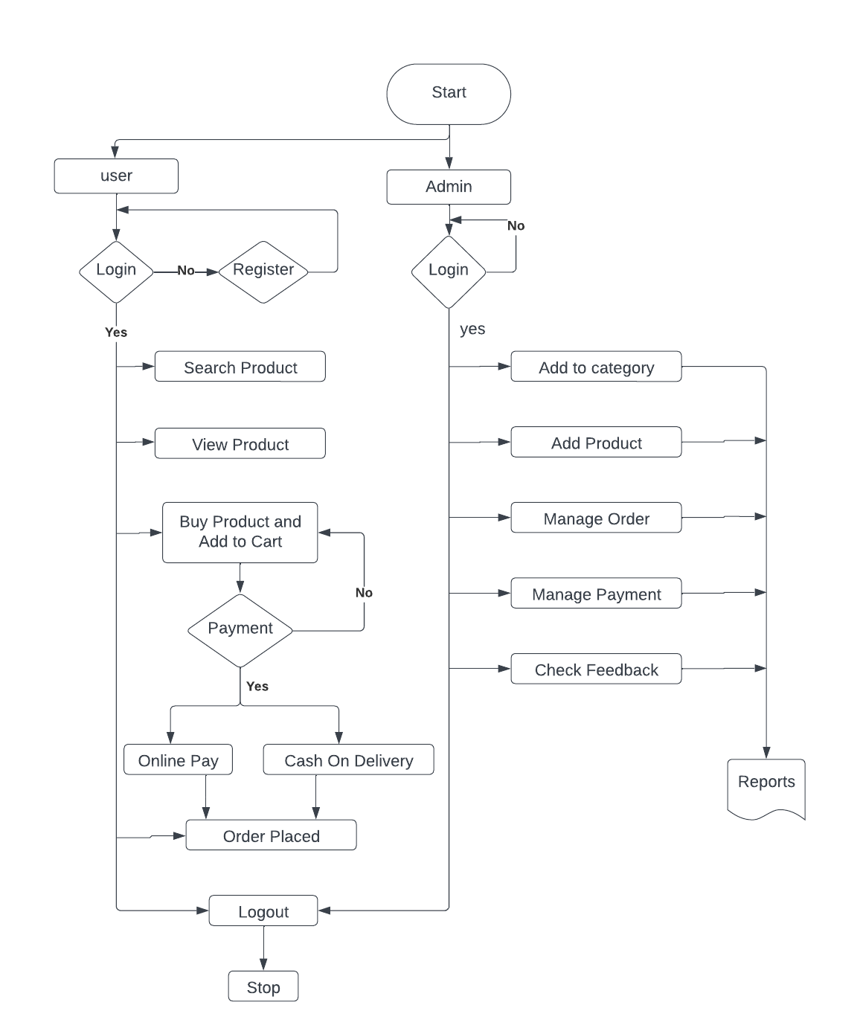

**USE CASE DIAGRAM**

A use case diagram illustrates the interactions between users (actors) and the system, showcasing various functionalities and how they are utilized. It provides a high-level overview of system functionality from a user's perspective. The Components used in Use- case diagram are Actors (representing users or external systems) and use cases (representing specific functionalities or actions).

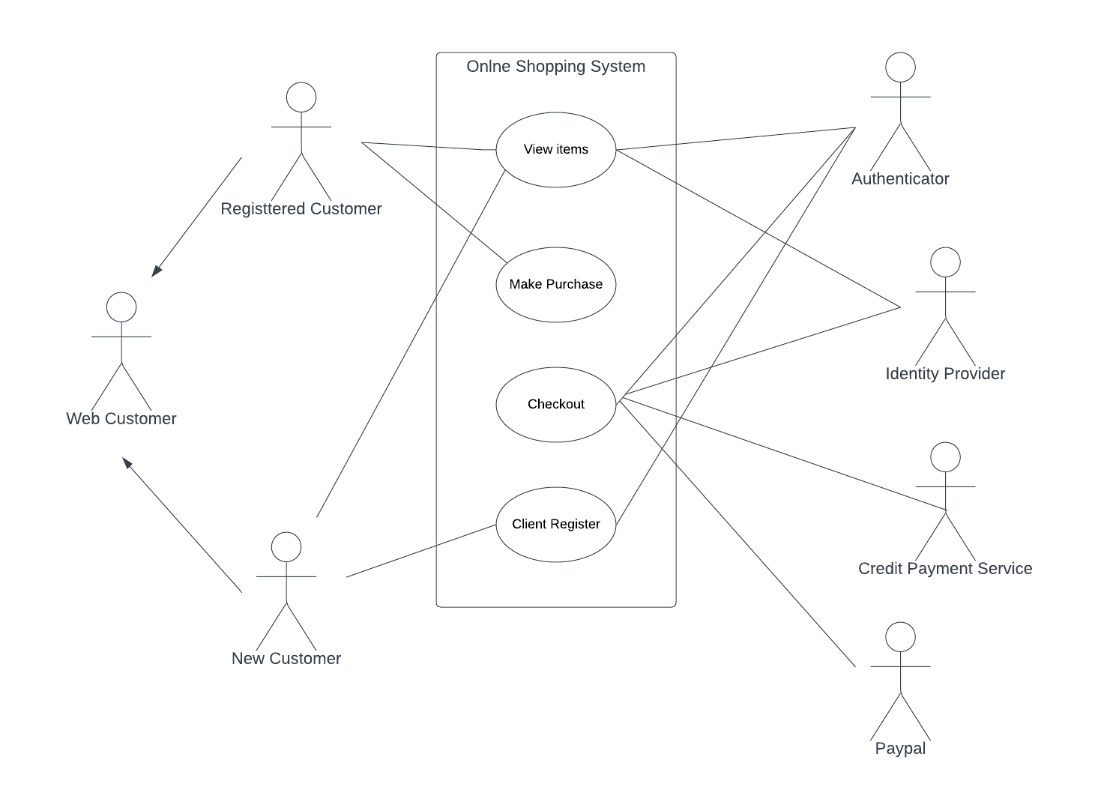

**CLASS DIAGRAM**

A class diagram illustrates the structure of the system, showing classes, their attributes, methods, and relationships. It provides a static view of the system's structure, focusing on its components and how they interact. The Components used in class diagram are Classes, attributes, methods, associations, inheritance, and dependencies.

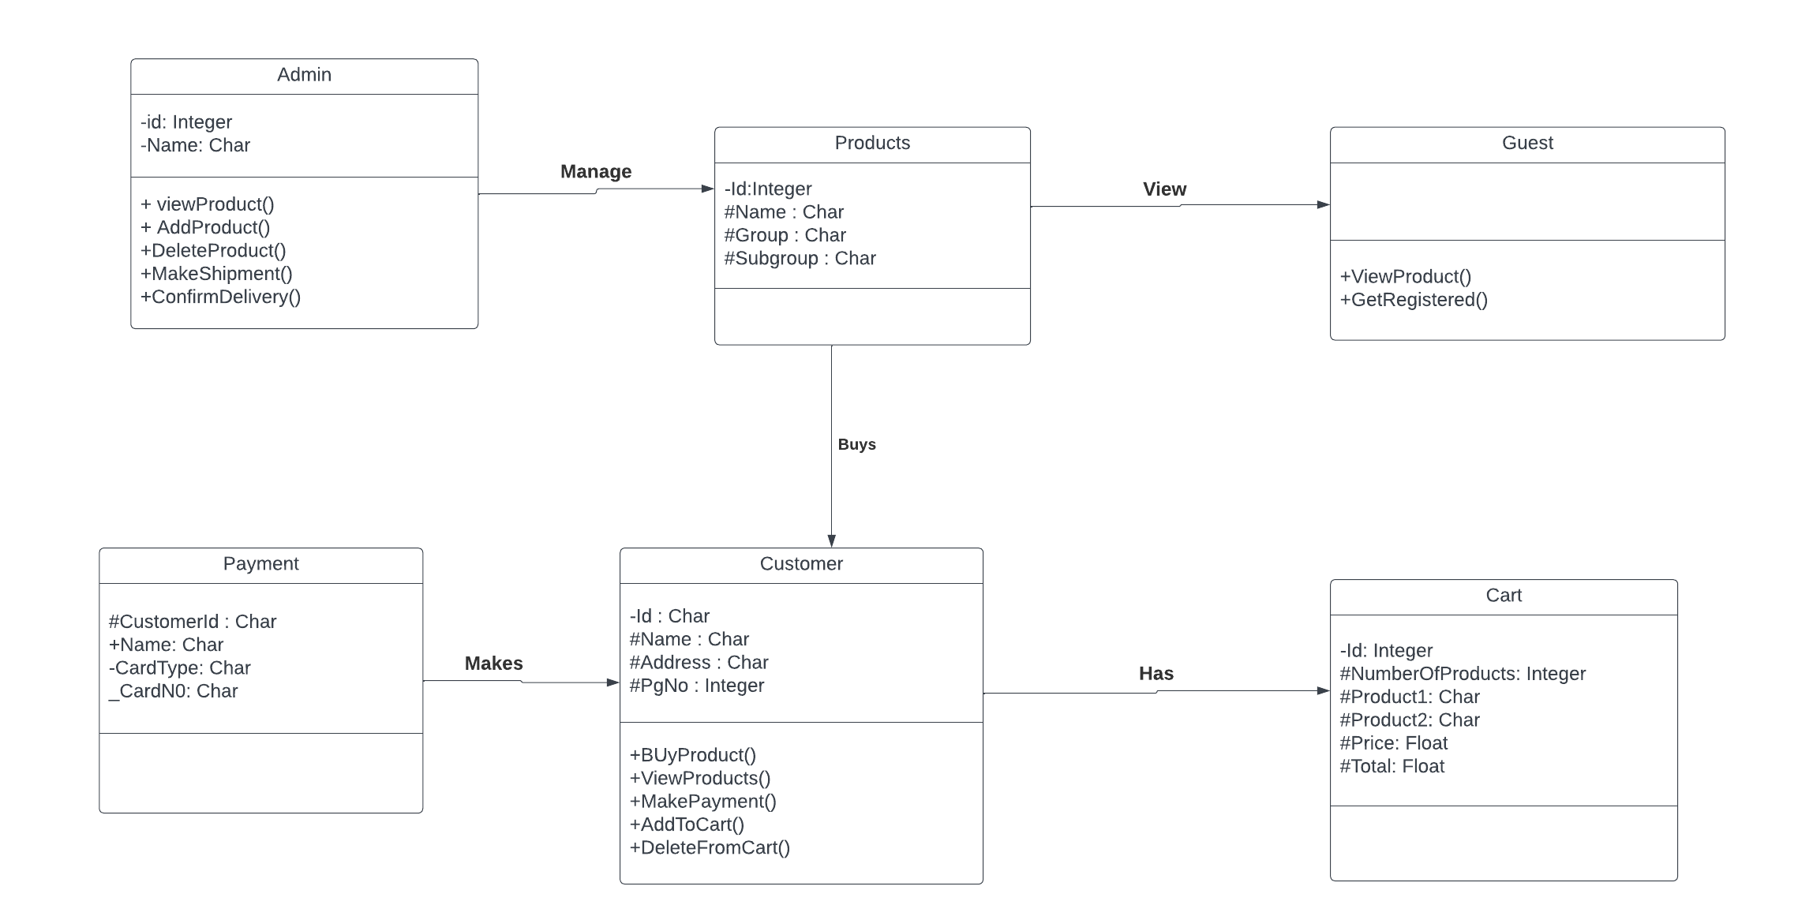

**SEQUENCE DIAGRAM**

A sequence diagram depicts interactions between objects in a sequential manner, showing the flow of messages exchanged over time. It provides a dynamic view of system behaviour, illustrating how objects collaborate to accomplish tasks. The components used are Lifelines (representing objects), messages (representing interactions), and activation bars (showing the lifespan of objects during interactions).

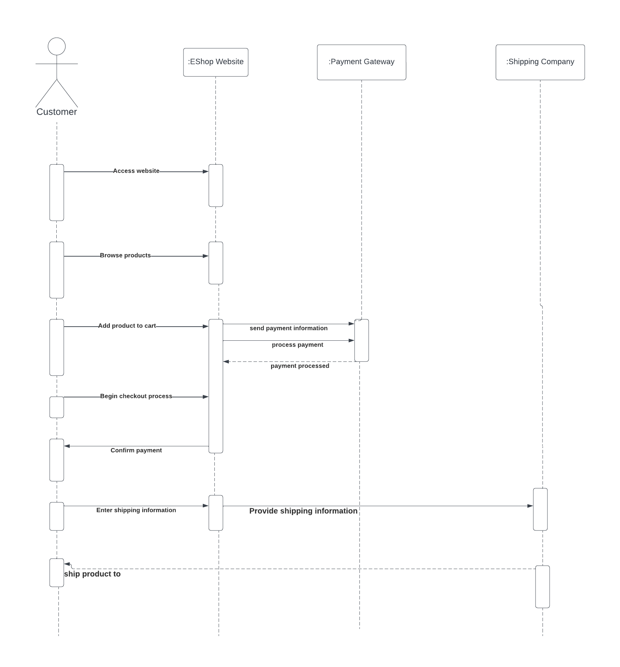

**CONCLUSION**

The Software Requirements Specification (SRS) document has outlined the functional and non-functional requirements for developing an online shopping mart. This SRS includes Use-case, Class and Sequence diagram which gives the diagrammatical representation for Online Shopping mart. The functional requirements define the core functionalities like product management, user management, browsing, shopping cart, checkout, order management, and content management. Non-functional requirements described essential characteristics like security, performance, scalability, availability, usability, and mobile accessibility. This SRS serves as a foundation for further development stages. Detailed technical specifications and design documents can be built upon this foundation. Stakeholder involvement, including customer feedback and team discussions, is crucial to refine and ensure the requirements align with the project's goals.